An Algorithm for Finding Tandem Repeats of Unspecified Pattern Size
Gary Benson
Nucleic Acids Research, Vol. 27, No. 2, pp. 573-580, 1999
Abstract
A tandem repeat is two or more contiguous, approximate copies of a pattern of nucleotides. Tandem repeats occur frequently in the human genome. They have been shown to cause human disease, may play a variety of regulatory and evolutionary roles, and are important laboratory tools. Extensive knowledge about pattern sizes, copy number, mutational history, etc. for tandem repeats has been limited because of the difficulty of detecting them in genomic sequence data. In this paper, we present a new algorithm for finding tandem repeats in DNA sequences without the need to specify either the pattern or pattern size. The algorithm is based on the detection of k-tuple matches.
- Introduction
Tandem repeat(s)：two or more adjacent copies of a gene or other nucleotide sequence, all arranged in the same orientation.
For example：
(Here the triplet CGG has been reproduced twice to form three identical, adjacent copies.) The result of a tandem duplication event is termed a tandem repeat.

- Methods
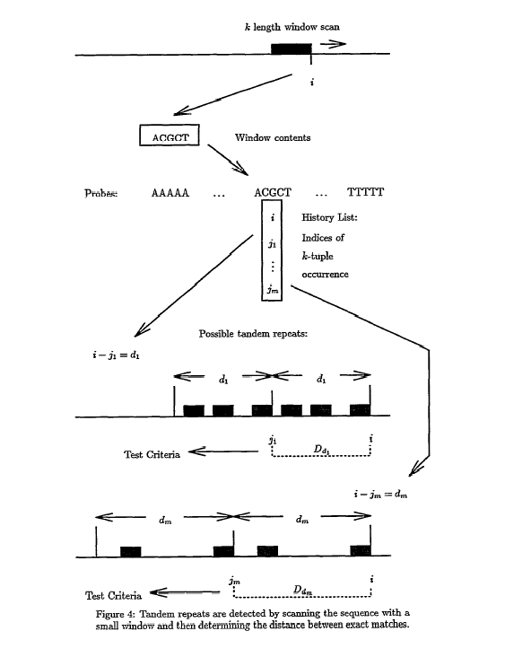

- Conclusion
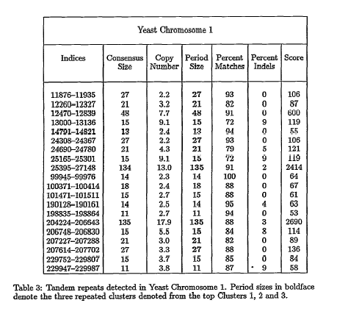
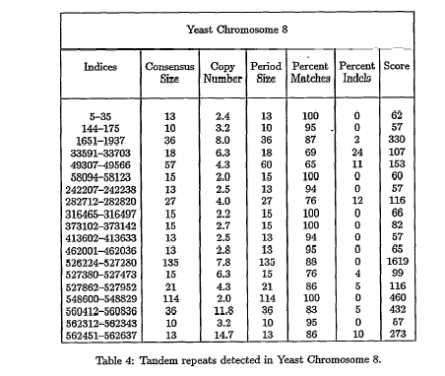
Created by:Chen-Shun Liu
Date:Mar. 19, 2004

